VALVE AS AN ACTUATOR
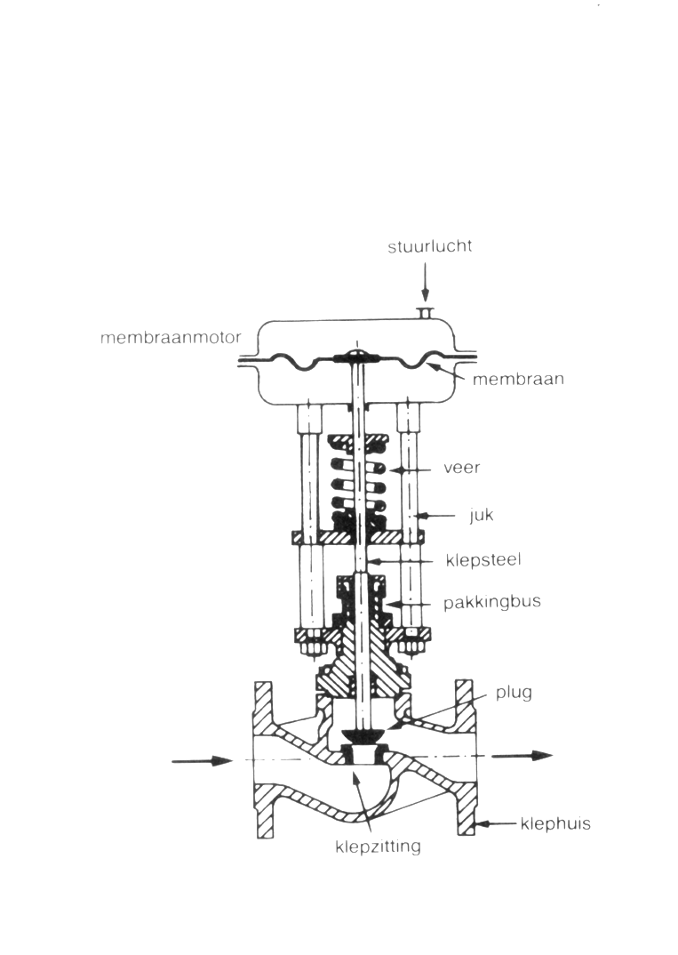
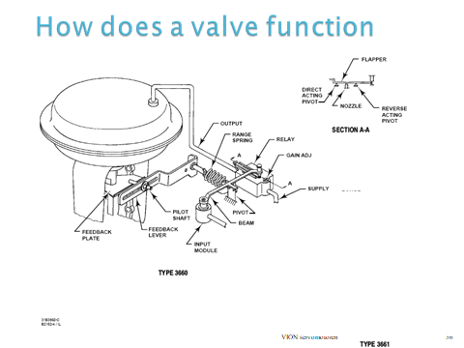
1)Analysis of of how a pneumatic valve works
By means of these two drawings try to foind out how the pneumatic valve in the laboratory works.

2) Setting a control valve
The automatic valve has to be set to control a level by means of the levelcontroller Milltronics.
- Set the levelcontrol
- Set the valve
- Connect the wiring and set the controller. Look at how the valve reacts but FIRST answer question d!!!
- What is MTL5041? What is the purpose and how does it work.
P | I | D | Valve reaction
1 | 0 | 0
1 | 0 | 1
1 | 0 | 5
10 | 1 | 0
10 | 5 | 1
10 | 10 | 5
50 | 1 | 0
50 | 5 | 1
50 | 10 | 5

