Temperature Temperature Cascade control
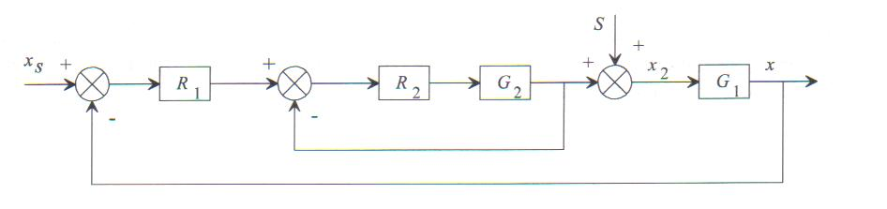
A cascade controlloop consists of two loops an inner loop called slave and an external loop called master.
The mastercontroller will set the setpoint of the inner loop, while the setpoint of the slavecontroller will be set by the operator.
- Look at how the loops are wired. How is the marshall wired?
- Change the PID values of the mastercontroller and look at how the slavecontroller and the process reacts.
P | I | D | stability | overshoot | settling time | offset | slave(setpoint)
1 | 0 | 0
10 | 0 | 0
20 | 0 | 0
30 | 0 | 0
40 | 0 | 0
10 | 5 | 0
10 | 10 | 0
10 | 20 | 0
10 | 30 | 0
10 | 40 | 0
10 | 20 | 5
10 | 20 | 10
10 | 20 | 20
10 | 20 | 30
10 | 20 | 40

- Change the PID values of the innerloop and lok at how the process reacts. What happens with the mastercontroller
P | I | D | stability | overshoot | settling time | offset
1 | 0 | 0
10 | 0 | 0
20 | 0 | 0
30 | 0 | 0
40 | 0 | 0
10 | 5 | 0
10 | 10 | 0
10 | 20 | 0
10 | 30 | 0
10 | 40 | 0
10 | 20 | 5
10 | 20 | 10
10 | 20 | 20
10 | 20 | 30
10 | 20 | 40

- Start up the fan which creates a perturbation. How reacts the process now.
P | I | D | stability | overshoot | settling time | offset
1 | 0 | 0
10 | 0 | 0
20 | 0 | 0
30 | 0 | 0
40 | 0 | 0
10 | 0 | 5
10 | 0 | 10
10 | 0 | 20
10 | 0 | 30
30 | 0 | 5
30 | 0 | 10
30 | 0 | 20
30 | 0 | 30

