Introduction to controltheory
What is control theory?
Control theory deals with the control of dynamical systems in engineered processes and machines. The objective is to develop a control model for controlling such systems using a control action in an optimum manner without delay or overshoot and ensuring control stability.
To do this, a controller with the requisite corrective behavior is required. This controller monitors the controlled process variable (PV), and compares it with the reference or set point (SP). The difference between actual and desired value of the process variable, called the error signal, or SP-PV error, is applied as feedback to generate a control action to bring the controlled process variable to the same value as the set point. Other aspects which are also studied are controllability and observability. This is the basis for the advanced type of automation that revolutionized manufacturing, aircraft, communications and other industries. This is feedback control, which involves taking measurements using a sensor and making calculated adjustments to keep the measured variable within a set range by means of a "final control element", such as a control valve.
Extensive use is usually made of a diagrammatic style known as the block diagram. In it the transfer function, also known as the system function or network function, is a mathematical model of the relation between the input and output based on the differential equations describing the system.
Control theory dates from the 19th century, when the theoretical basis for the operation of governors was first described by James Clerk Maxwell.[2] Control theory was further advanced by Edward Routh in 1874, Charles Sturm and in 1895, Adolf Hurwitz, who all contributed to the establishment of control stability criteria; and from 1922 onwards, the development of PID control theory by Nicolas Minorsky.[3] Although a major application of mathematical control theory is in control systems engineering, which deals with the design of process control systems for industry, other applications range far beyond this. As the general theory of feedback systems, control theory is useful wherever feedback occurs - thus control theory also has applications in life sciences, computer engineering, sociology and operation research. (source[1])
What is the goal of control theory
Control theory is a theory which has as a goal to create a control loop that controls a dynamical system in general, a process specifically spoken.
Th goal is by controlling a control parameter to control the process. This control parameter can be a lot of things as for instance pressure, temperature, flow, level, current,…
If someone wants to control a process and uses a control loop, this control loop shows some properties which are stability, precision and speed.
In order to control the loop a controller is used. A standard controller is what is called a PID controller and has three functionalities
P: Proportional and is a constant P called the gain and is responsible for the stability
I: Integrator and is a time constant called the integration time τ_{i} and is responsible for the precision
D: Differentiator and is a time constant called the integration time τi and is responsible for the speed

Trend
Control loops show reaction and need time to reach the control parameter at which it was set.(SP:setpoint) To study its reaction we use what is called a trend, the reaction of the change in time.
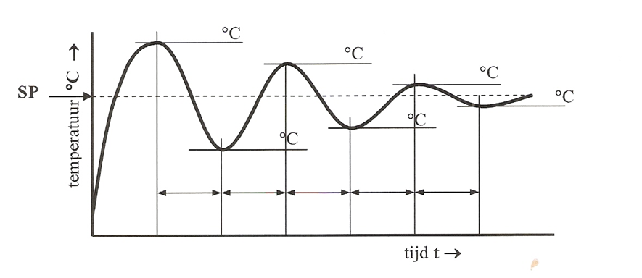
On this figure which is the reaction of a process thus a trend draw:
Settling time: time needed by the control loop to settle whitin 5% deviation of the set point
Response time: time needed by the control loop to reach the value of the set point fort he first time
Overshoot: maximal value reached during the adjustment
Offset: the static deviation if the control loop cannot control precise
Basic elements in a control loop (source[1])
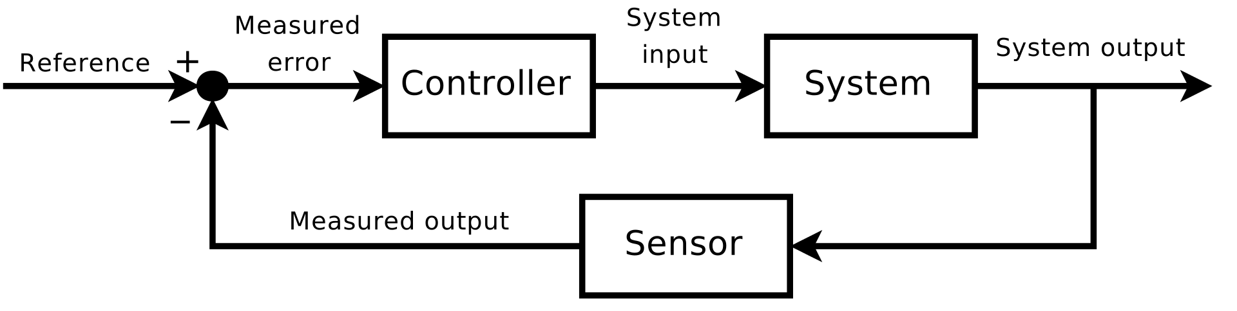

The sensor measures the output and send the signal back tot he input and compares input with output and this difference has to be……

PID controller
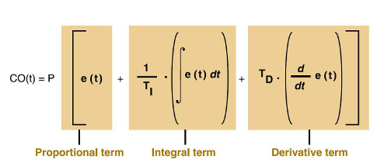
Source[3]
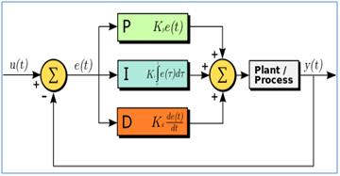
Source[2]

Different elements in a control loop
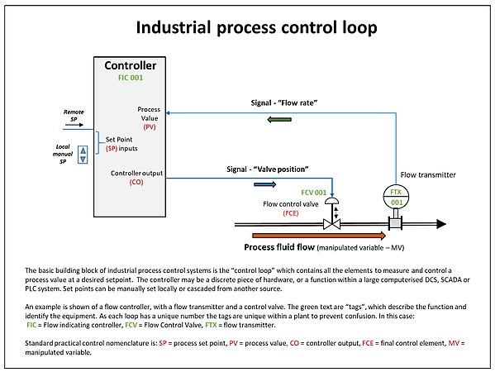
Source[1]
References
[1] https://en.wikipedia.org/wiki/Control_theory(10/9/2020,13:50h)
[2] https://en.wikipedia.org/wiki/PID_controller(10/9/2020,23:07h)
[3] https://www.controleng.com/articles/understanding-pid-control-and-loop-tuning-fundamentals/(10/9/2020,23:09h)

