Temperature control by means of on-off control.
- Setting the control values.
For example if you try to control the temperature of a vessel filled with about three liters of water. You try to control it by means of an on-off controller. What are the control-parameters in this case?
Explain.
- Measuring an on-off circuit.
You take the on-off control circuit where a volume of air is heated by means of a lamp. You look up what each component in this circuit does and you measure this circuit. Where do you measure signal and where do you measure signal. How large are the currents/voltages at each point. Explain. Sketch the a block diagram of this controlloop.
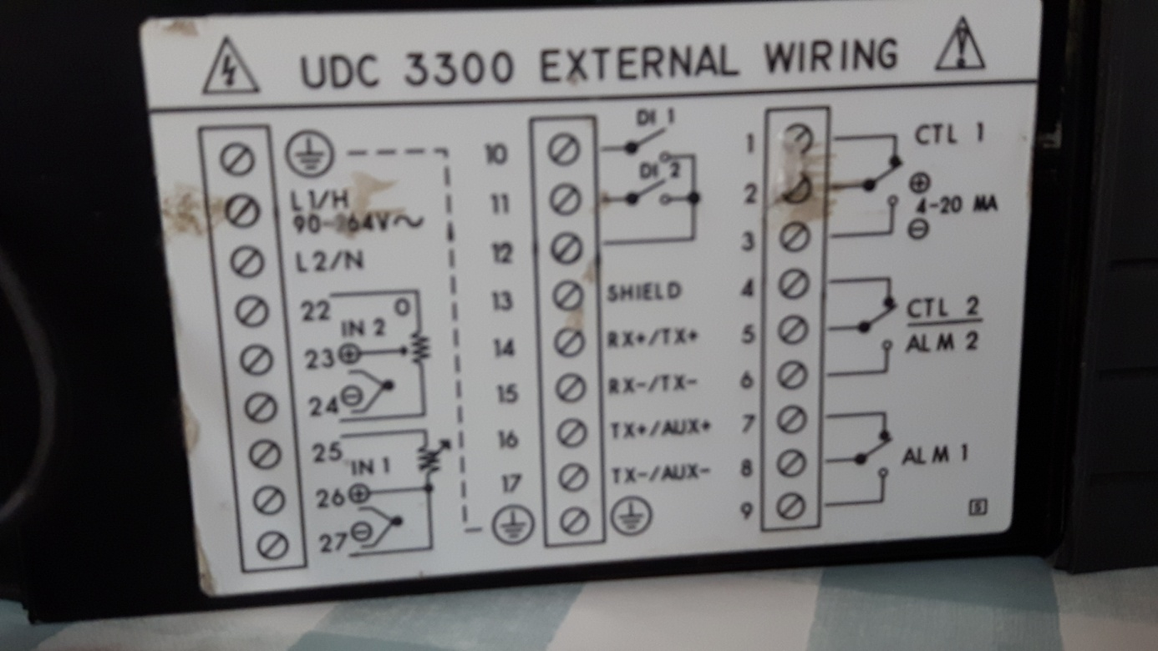
Fig.1:Controller UDC 3300
Draw the electric scheme of this system

