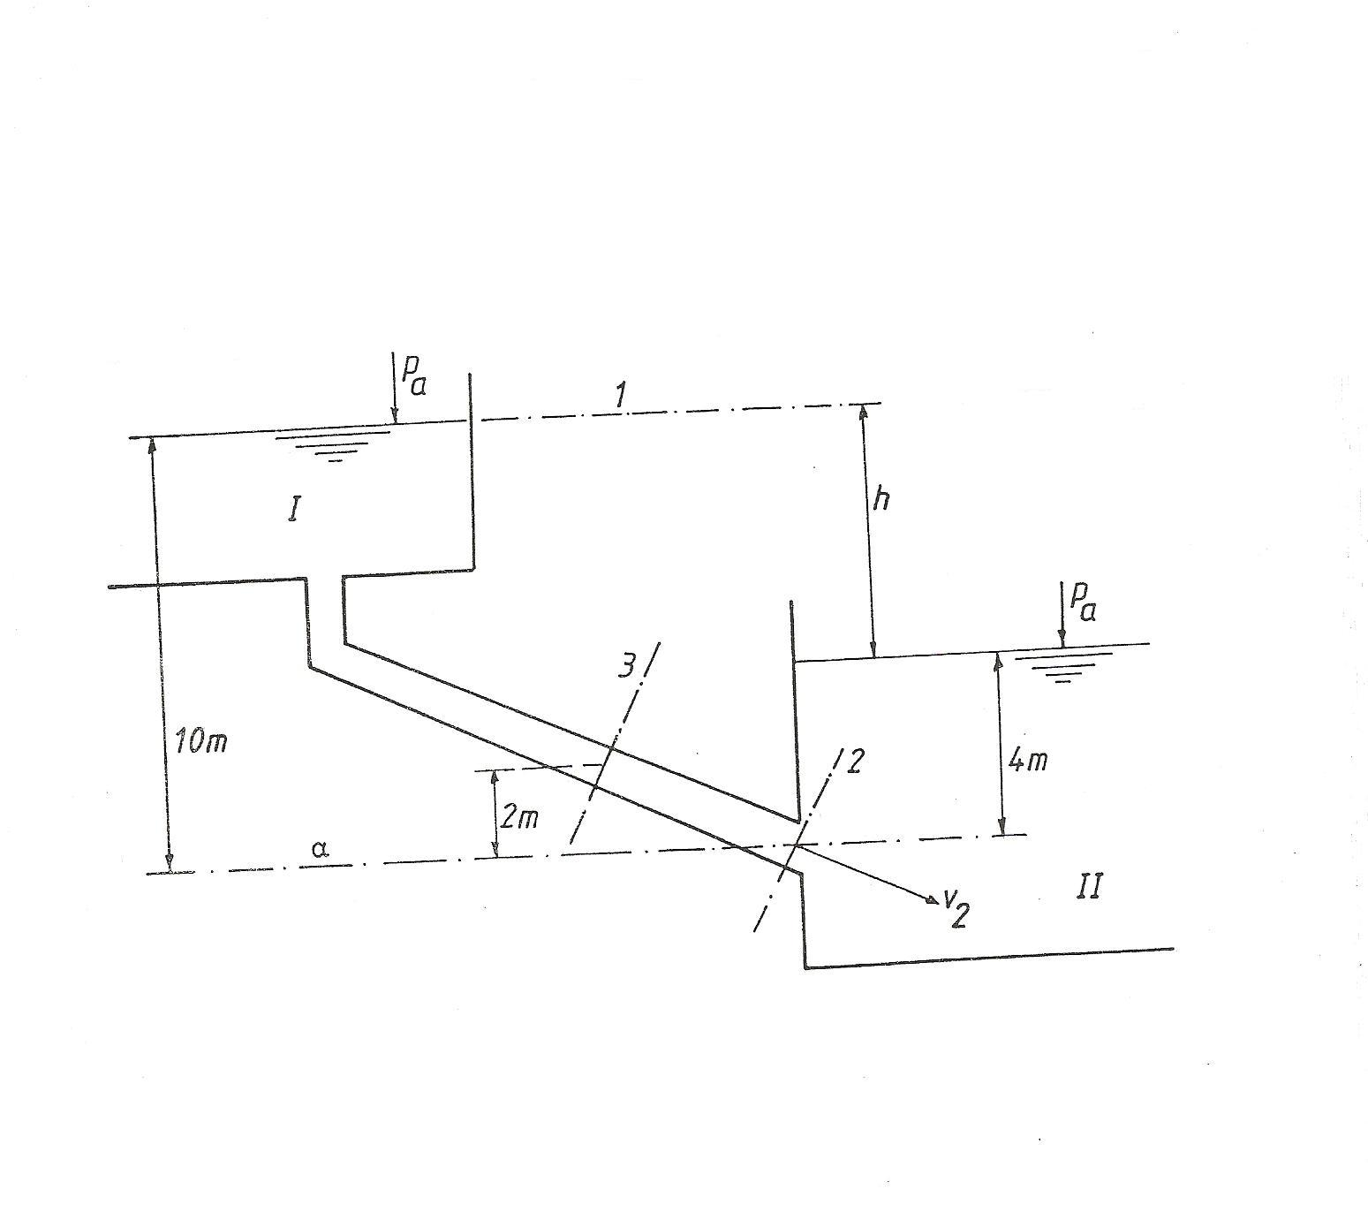
Calculate the pressure in point 3 and the speed in point 2 for the situation as drawn in the figure above.

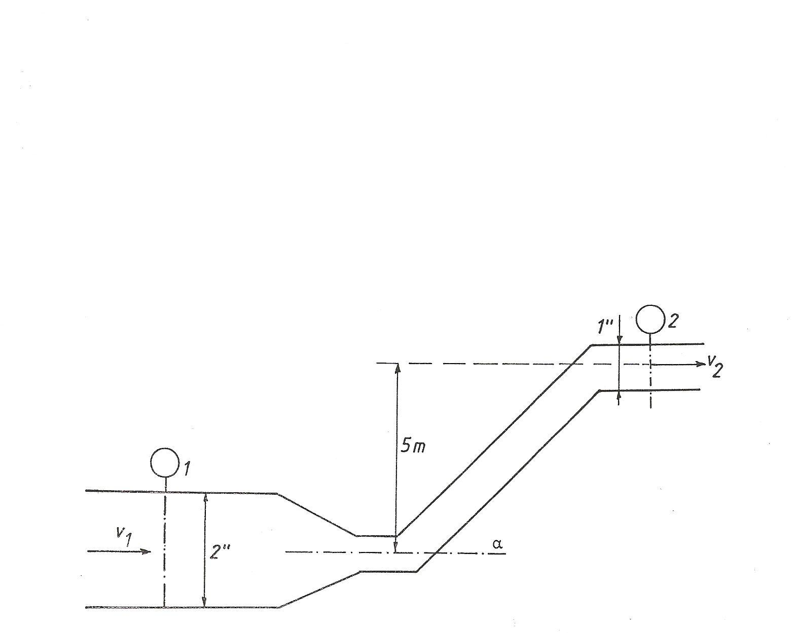
Calculate the pressure in point two if the pressure in point 1 is 4.8bar and the liquid in the duct has a density of 1200kg/m³.
- If v₁=0m/s
- If v₁=2m/s

