Ex 1
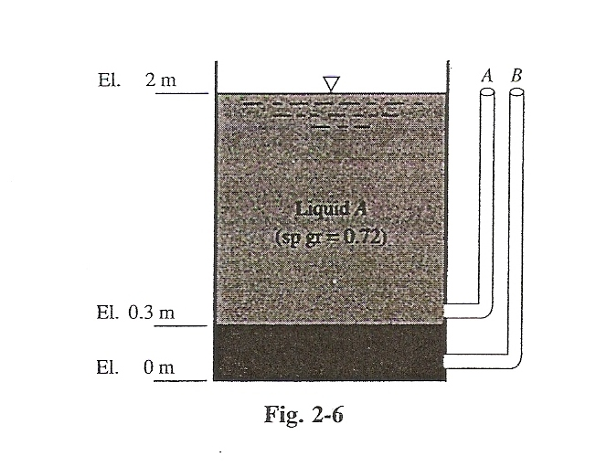
Two imiscible liquids with specific gravity 0.72 and 1.2 are in contact with repective tibes A and B. Calculate the heights in A and B.
Ex2
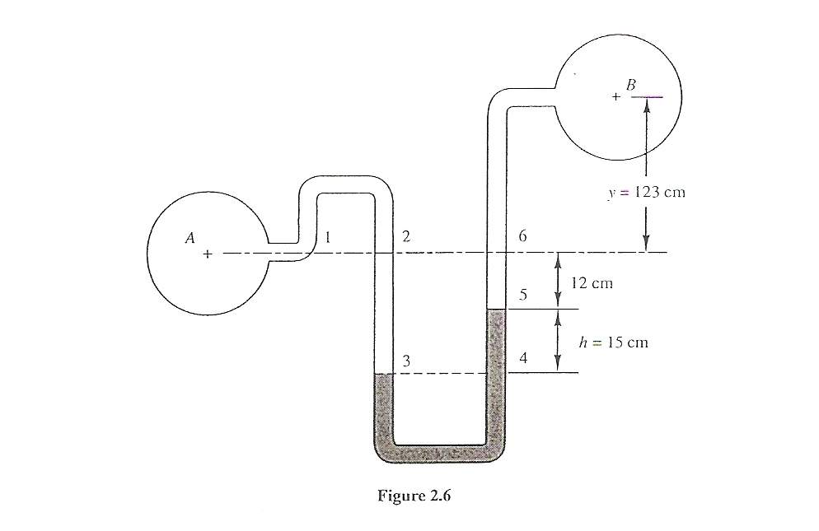
Calculate the pressure difference between A and B

Ex3
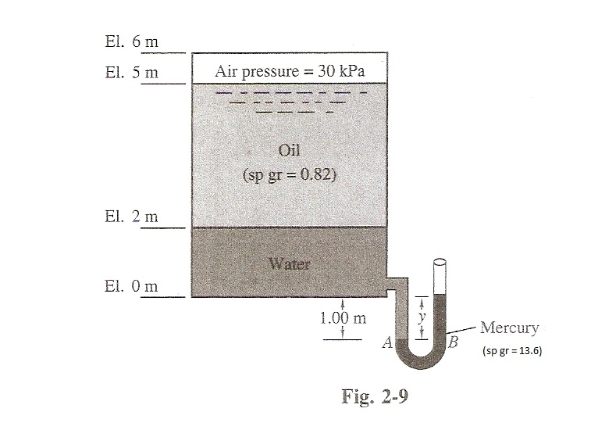
Calculate y
Ex 4
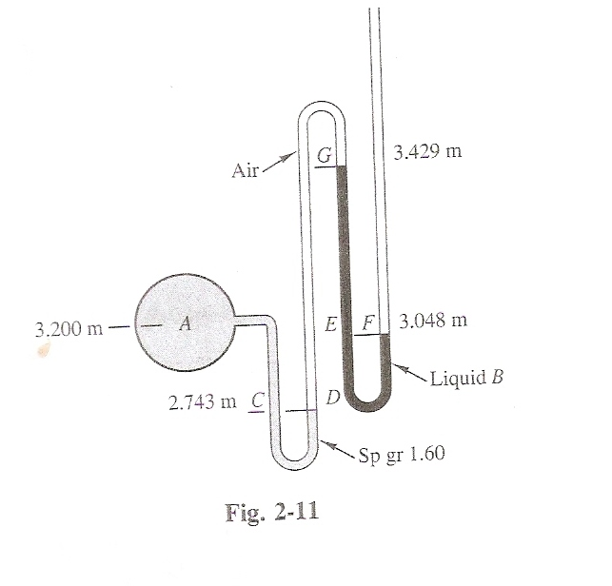
Calculate the sp gr of liquid B

Ex5
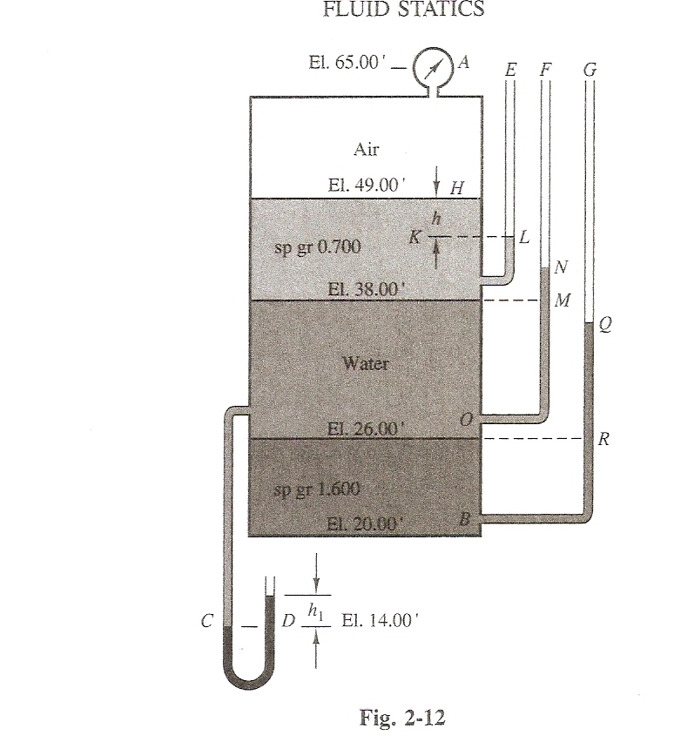
Calculate height in tube E,F and G and h₁
Ex 6
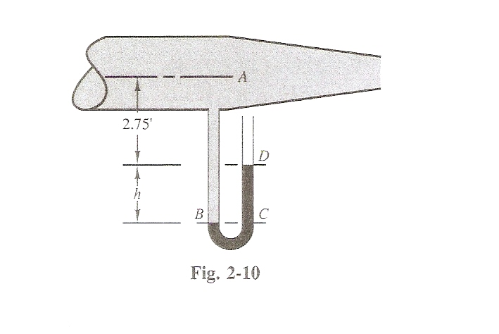
Calculate h if
- the presuure in a is 0.96 bar and there is no fluid flow.
- There is an ideal fluid flow with v=3m/s and the tube makes contact with the fluid after the convergent. D₁=20cm and D₂=10cm.

Ex 7
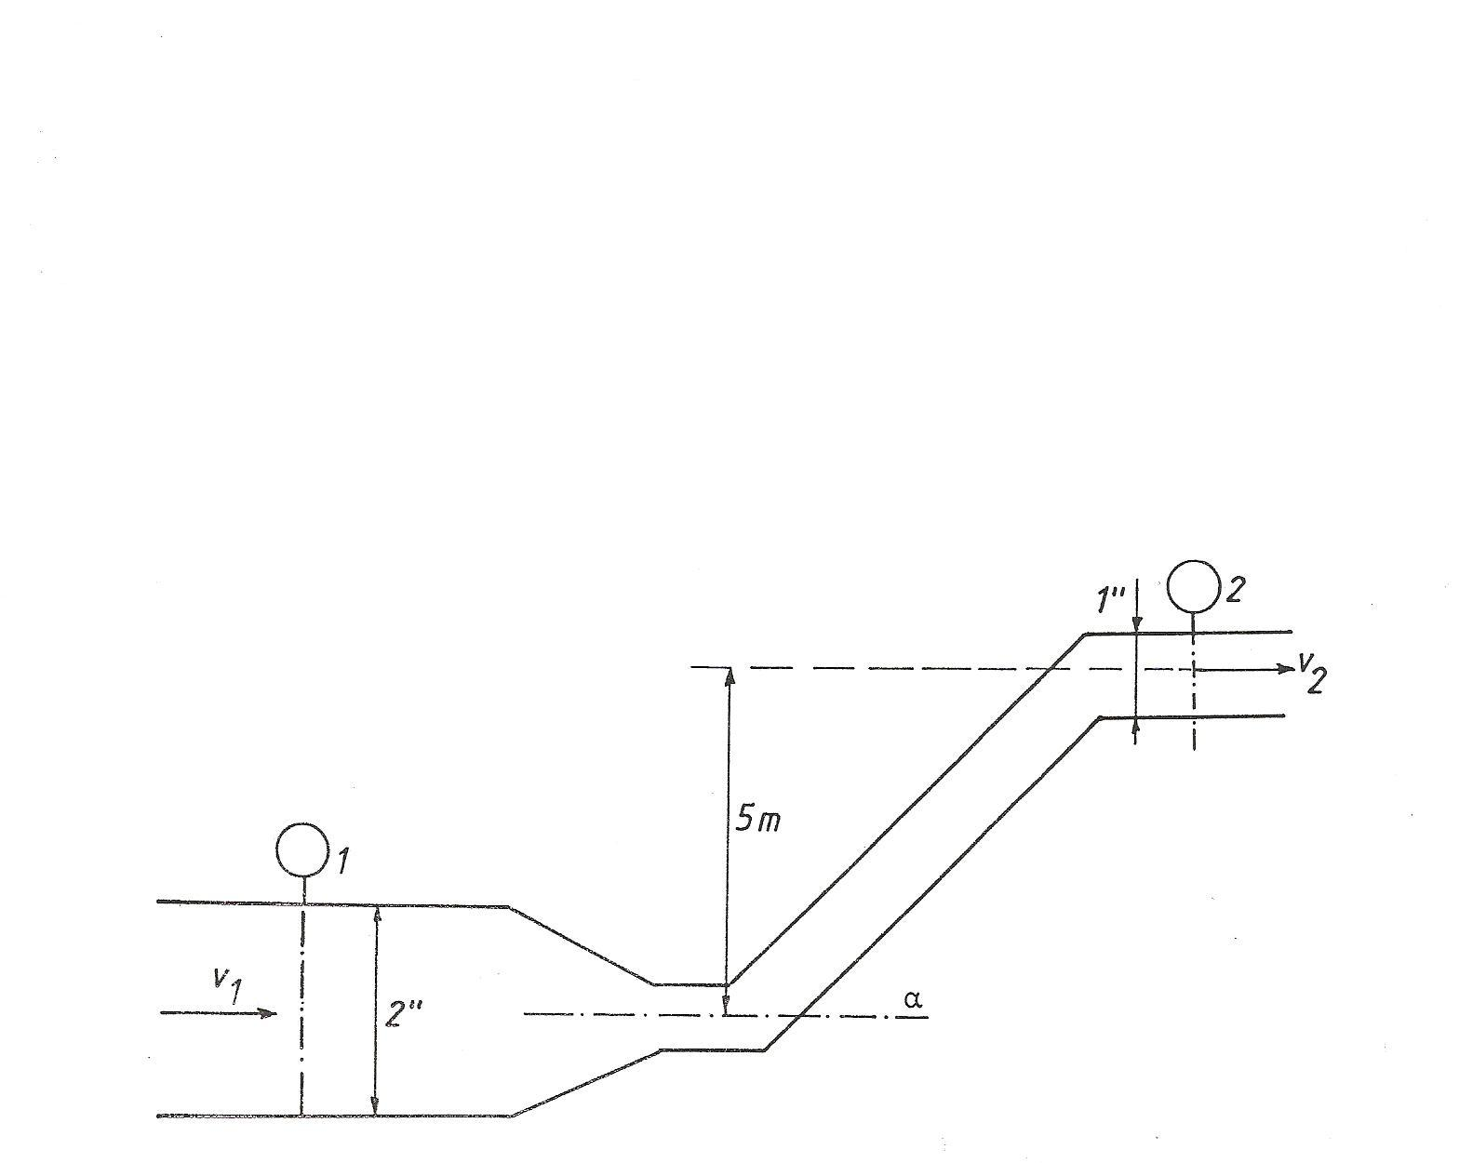
A tube has a diameter of 2m and this diameter decreases to 1m. The tube is filled with water. Manometer 1 shows a pressure of 4.8bar. What pressure will be show non manometer 2 if
- There is no flow in the tube
- There is a flow: v₁= 2m/s

Ex 8
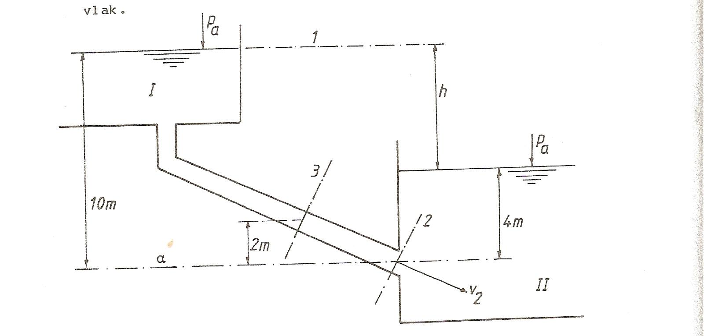
What is the speed of the fluid at point 2 (so v₂)
Calculate the pressure at point 3
Ex 9
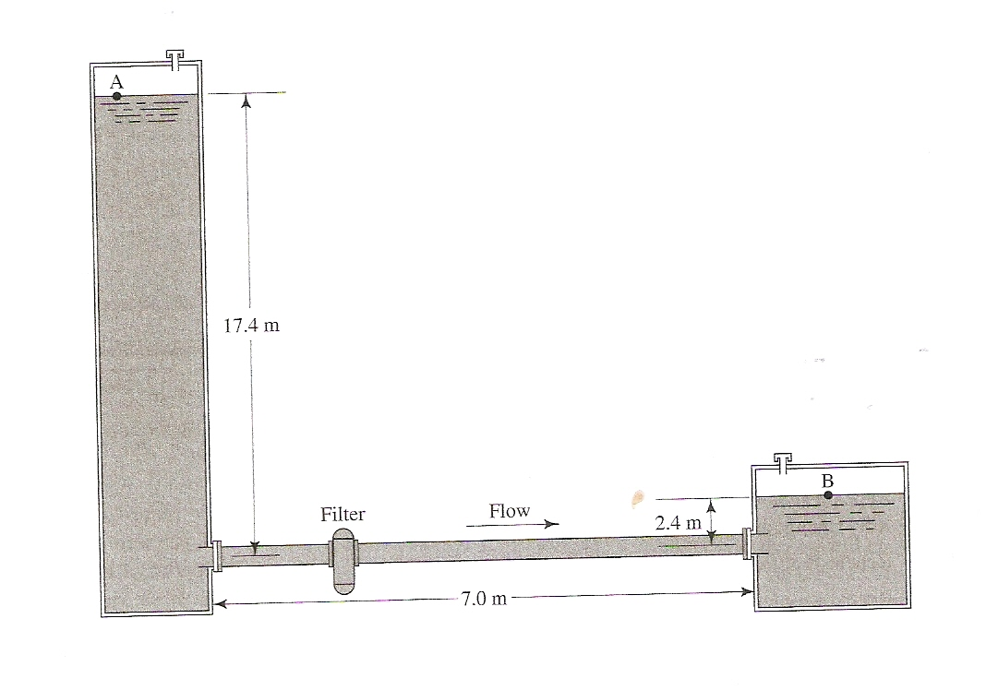
Calculate the flow of the water in reservoir B if the pressure at A is 3bar and at B 1.5bar
What pressure do we need to have at A if the flow is 20m³ per hour.
(section of the pipe is 20cm)

