Exercise 1 (exam 2006)
Water (ν=1,1.10⁻⁶m²/s) is pumped from open reservoir A to open reservoir B where the difference in height is 15m. The head of the pump is 20m.
Total length straight pipe :60m; d= 0,4m; roughness ε:0,00016m; intake: ξ=0,5; curve 90°:ξ=1.5; separation: ξ=0,6, combination: ξ= 0,4; outlet: 0,9
Length of parallel pipes: l=40m each and d=0,3m roughness ε=0,00015m
Calculate the flow from A to B.
For the calculation of losses, use the formula for transition area
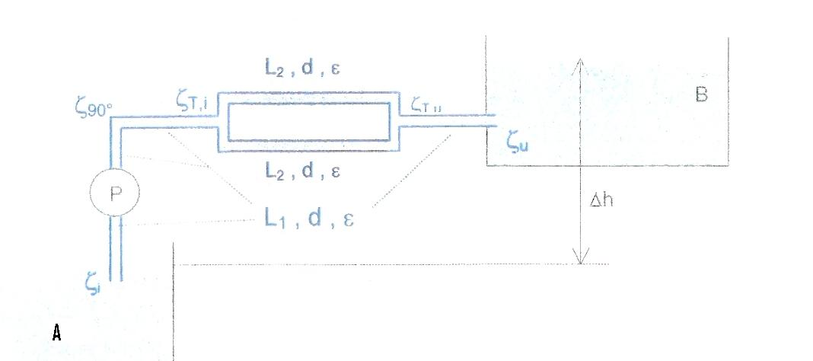

You show your calculations on an excell sheet (solution:v1=4.576m/s)

Exercise 2 (exam 2010)
Liquid with density 789kg/m³ and viscosity ν=7,1.10⁻⁷m²/s is pumped from reservoir A (p_{A}=2bar) to open reservoir B with Δh=10m. The head of the pump is 213,88m. Calculate the flow in the system.
Suction line: L₁=15m, d₁=0,1m,ε₁=0,05m; ξ(in)=0,5
Discharge line: L₂=200m, d₂=0,04m; ε₂=0,1mm; ξ(90°)=0,57; ξ(valve)=6,64; ξ(out)=0,4
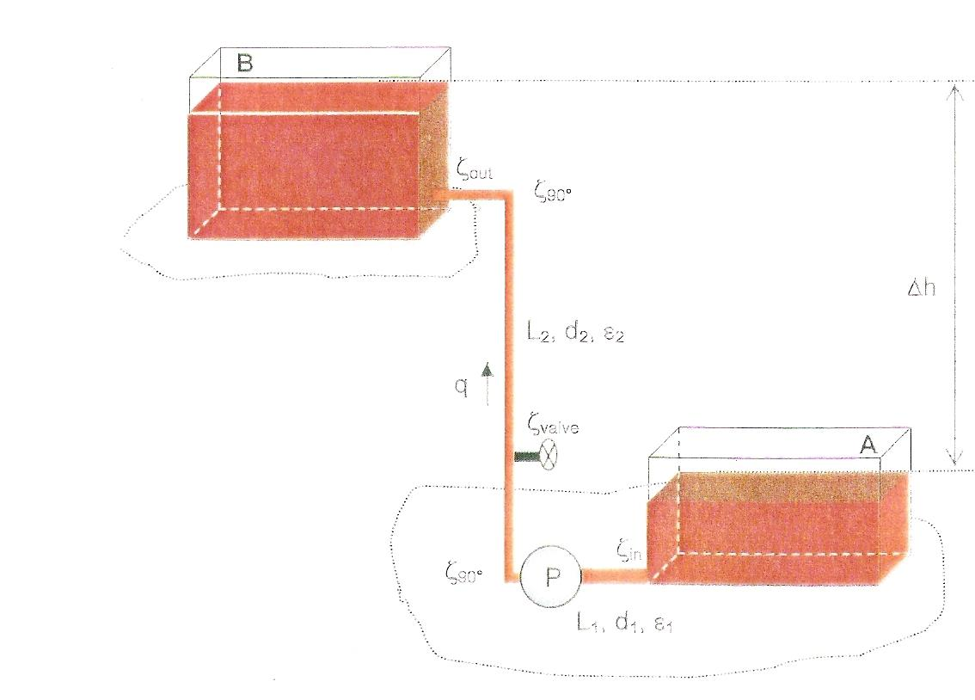

For the calculation of losses, use the formula for transition area
You show your calculations on an excell sheet (solution:v1=0.068m/s)

Exercise3 (exam 2009)
Liquid flows from an open reservoir A through a pipeline to point B. In this pipeline a turbine is placed 5 m under the upper level of the liquid. Calculate the power the turbine supplies. If the flow is 0,3255m³/s. The length of the pipe B is 0m, so consider a free flow on the exit.
Density ρ=900kg/m³; viscosity: ν=2,5.10⁻⁶m²/s; suction line 6m; ξ(90°)=0,45;ξ(in)0,5, roughness ε=0,2mm; d=0,3m
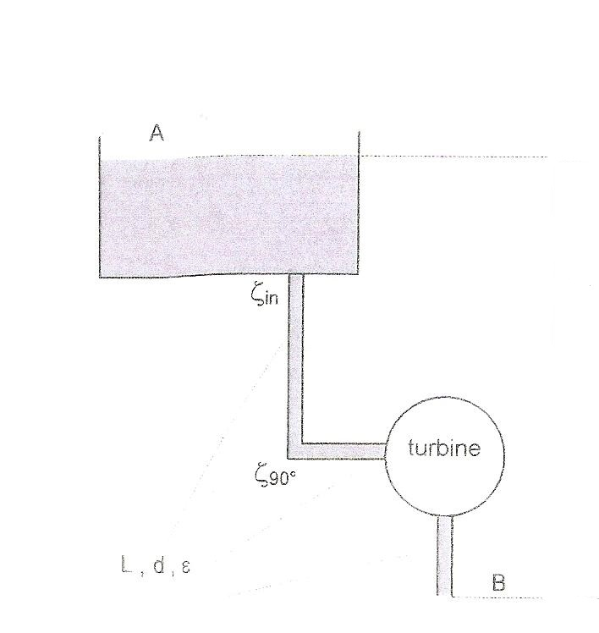

For the calculation of losses, use the formula for transition area
You show your calculations on an excell sheet (solution:p2=39330Pa, P=19.5kW)

Exercise 4 (exam2008)
Water (ν=10⁻⁶m²/s) is pumped from 2 closed reservoirs A and B with a Δp= 0,56bar to open reservoir C where the surface of the water lies at Δh=4m. Both reservoirs in the suction line are connected with identical pipelines. D=0,4m; roughness ε=0,00053m and total length l= 16m. Entrance in the pump has a pressure drop : ξ(in)=0,6. Pump has a head of 20m. Exit of the pump has a pressure drop ξ(out)=0,3. The discharge line has diameter:0,5m; ε=0,00053m; L=40m.
Calculate the flow to C (4 meaning full digits after the comma)
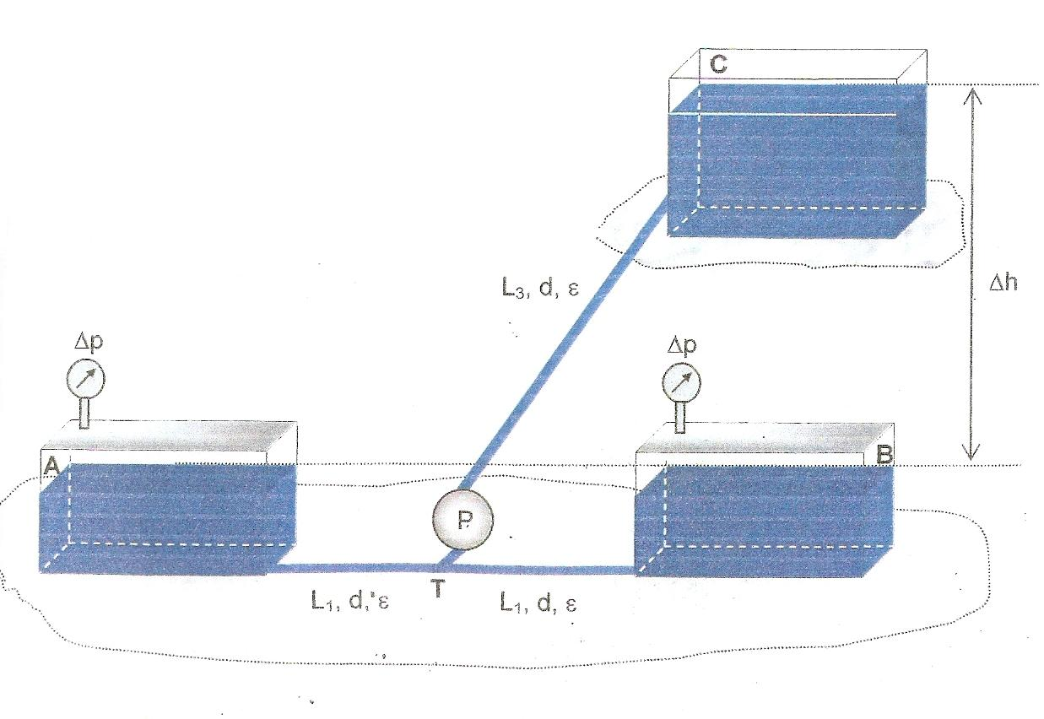

For the calculation of losses, use the formula for transition area
You show your calculations on an excell sheet (solution:v1=3.912m/s)

