Exercises Bernouilli
1)Tw o large reservoirs are connected. Above the surface there is atmospheric pressure.
a)What is the speed of the liquid at point2?
b)What is the pressure at point 3?
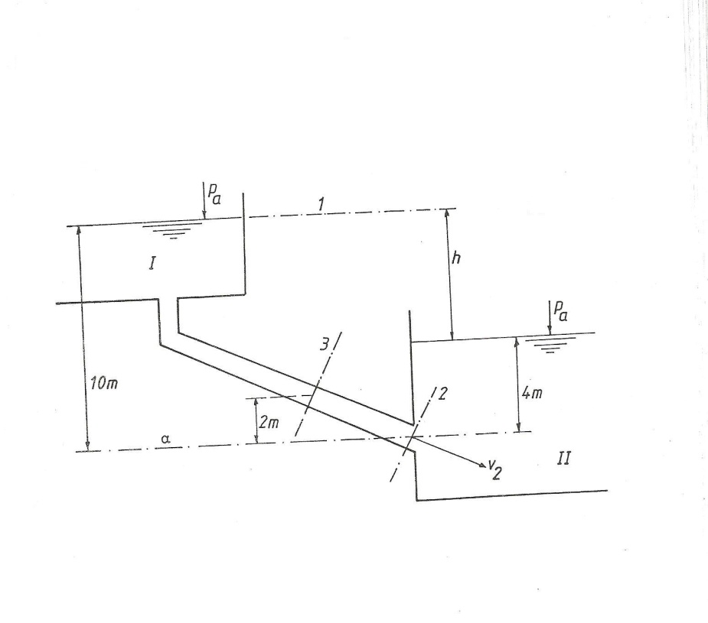
2)A tube has a diameter of 2”.The diameter decreases to 1” and increases in height to 5m.In the tube we have a liquid with density ρ=1200kg/m³. Manometer 1 reads a pressure of 4.8bar. What pressure will we read on manometer 2 if
a)v=0
b)v=2m/s in the 2”tube.
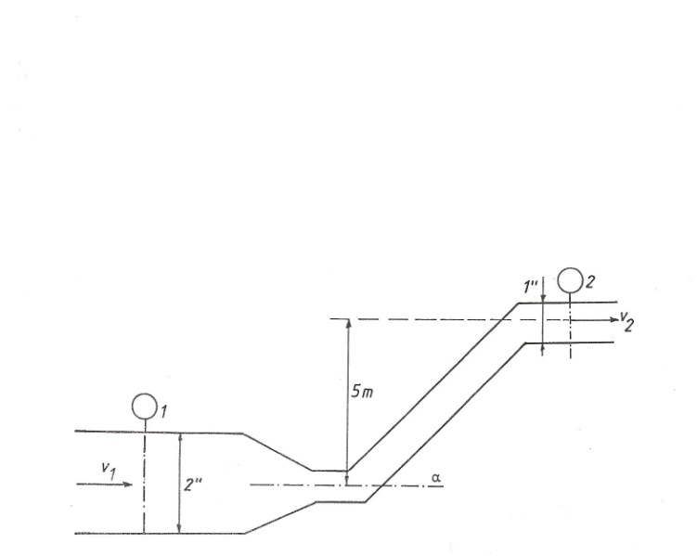
3)In the system of the figure below is running oil with density ρ=761kg/m³ from reservoir A to reservoir B. In the pipe we have losses considered as written below
Calculate
a)the flow
b)the pressure in point C
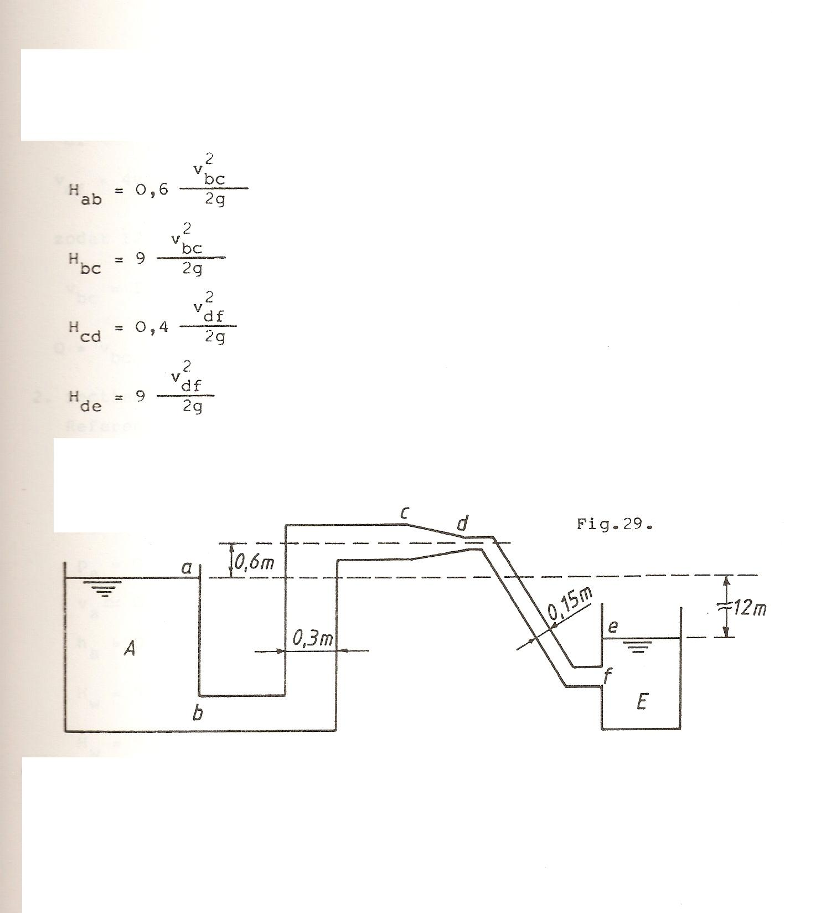

4)In the figure below oil is running from the reservoir. Diameter of the pipe is 30mm and length 6m.
Viscosity of the oil is 75cSt. Calculate the flow
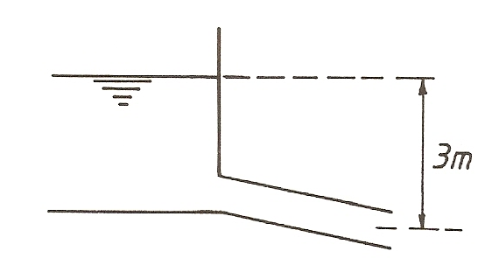
5)A suctionduct (k=0.1mm) of a cenrifugalpump has a diameter of 200mm and is composed of
- a straight tube of length 6m
-a suction filter with a non return valve type 1(s/t=0.2)
-a curve with radius 400mm
Through the duct flows 60l water per second at a temperature of 15°C. Calculate the underpressure in section 2.
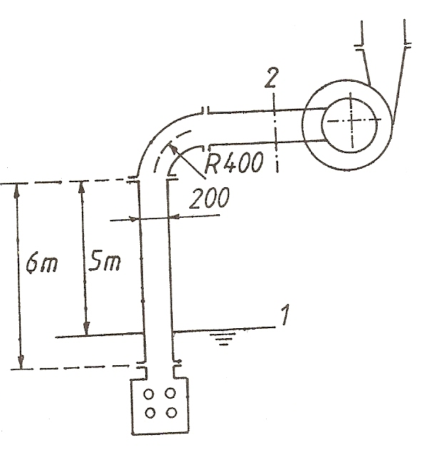

6)A simple duct with diameter 300mm and a length of 1500m connects two reservoirs with a difference in height of 20m. through this duct there is a flow of 0.14m³/s. calculate the new flow if the systems changes like in the figure below.
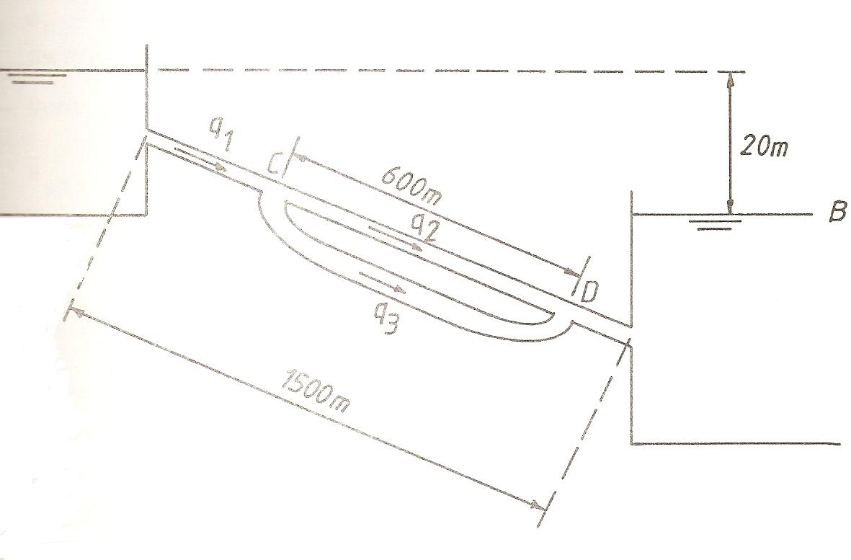

7)In the installation as drawn below the pump has to deliver a flow of 015m³/s.
Calculate
a)resistance of the different ducts
b)flow in the different ducts
c)pressure in A and E
d)the lift and the power of the pump
