Centrifugal pump
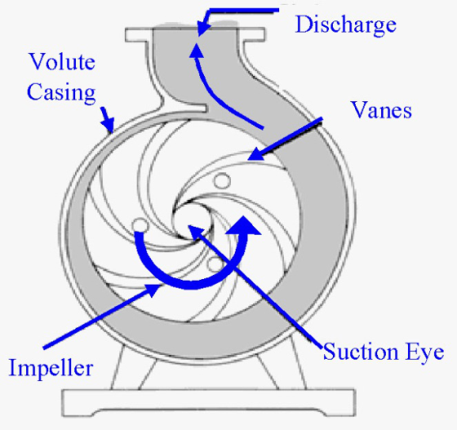
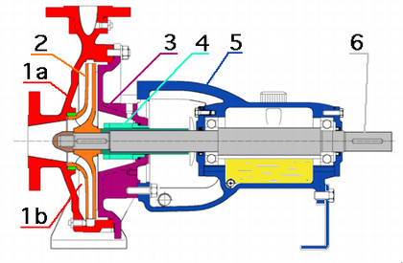
Advantages:
+cheap also in maintenance
+smaller pumps can deliver high pressures
+flow stays relatively constant at pressure fluctuations
+simple flowcontrol
+can be used for heavily polluted liquids
Disadvantages:
-can’t run dry
-can’t deliver with gas in the liquid

Monopump or progressive cavity pump
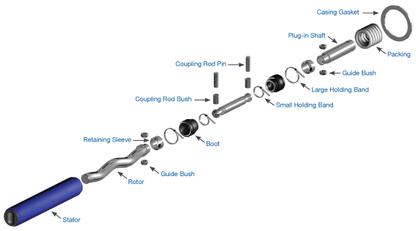
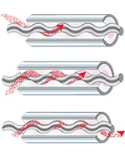
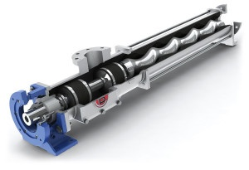 The progressive cavity pump principle is ideal for handling slurries, viscous, shear sensitive or two or tri phase mixtures or when applications require, significant suction lift capabilities.
The pump design is ideally suited for both low to high flow applications and also allows for the development of multi-stage pumps that increase the pressure handling capabilities.

Lobe pump
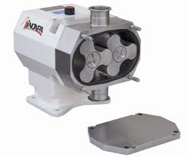
Advantages
- Pass medium solids
- No metal-to-metal contact
- Superior CIP/SIP capabilities
- Long term dry run (with lubrication to seals)
- Non-pulsating discharge

Disadvantages
- Requires timing gears
- Requires two seals
- Reduced lift with thin liquids

Plungerpump
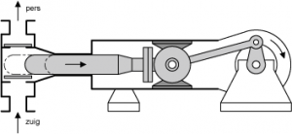
Pistonpump
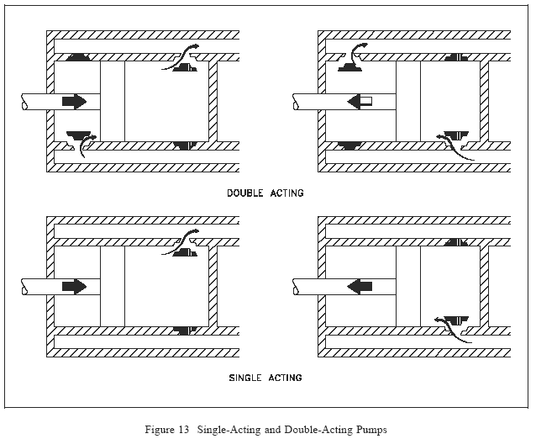

Advantages | Disadvantages
- Wide pressure range - can achieve very high pressures | - High operating and maintenance costs.
- Pressure can be controlled without affecting flow rate. | - Typically heavy and bulky
- Pressure and flow rate changes have little effect on performance. | - Typically only handles lower flow rates
- Capable of moving viscous fluids, slurries, and abrasives with proper valve design. | - Pulsating flow
Gear pump
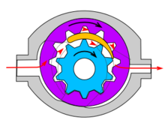
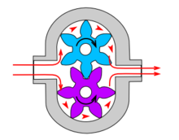
Advantages
- High speed
- High pressure
- No overhung bearing loads
- Relatively quiet operation
- Design accommodates wide variety of materials
Disadvantages
- Four bushings in liquid area
- No solids allowed
- Fixed End Clearances

Rotary vane pump
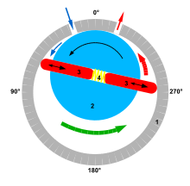

The disadvantage of rotary vane vacuum pump
1, the efficiency is low, generally around 30%, better can amount to 50%.
2, vacuum degree is low, not only because this is limited by the structure design , but the more important is restricted by working liquid saturation vapour pressure.
3, use water as working fluid, the limit pressure can reach 2000 ~ 4000 pa. ues Oil as working fluid, the ultimate pressure can rearch to 130 pa.

The advantages of rotary vane vacuum pump
1, because of the rotary vane type vacuum pump in the gas compression is isothermal, then can the pumping flammable, explosive gas.Because there is no exhaust valve and the friction surface, therefore can be pumping gas with dust, non-condensable gas and water mixture.With these outstanding features, although its efficiency is low, is still widely used.
2, extraction rate: 0.43-560 m3 / min
3, the minimum suction pabs: 33-160 hpa
4, use the temperature: - 10 ℃ and 40 ℃
5, supporting power: 7.5 - 560 kw
6, over-current material: cast iron, stainless steel

Peristaltic pump
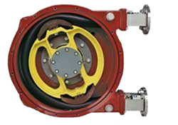

Advantages for peristaltic pumps
- The only part of a peristaltic pump that comes in contact with the liquid is the tubing. This maintains the sterility of fluid and the pump
- More than 20 tubing formulations and sizes are available for peristaltic pumps for excellent compatibility with a variety of liquids
- Self priming - peristaltic pumps can draw fluid into the tubing when starting dry, up to 8.8 m suction lift. Other pumps require user to fill pump and suction line with fluid before use which can be inconvenient and also create potential for hazardous spills or contamination
- Gentle pumping action - low shear - makes a peristaltic pump ideal for handling cells and large proteins, as the pumping action will not damage the content
- Variable speed options available on some peristaltic pumps, making those ideal for dosing applications
- The fluid does not contact the peristaltic pump so there are no parts to clean such as valves, diaphragms, seals etc. All you have to do is clean or replace the tubing. This easy tubing replacement means reduced maintenance times
- A peristaltic pump is non-siphoning which means that they prevent back flow into the system. This promotes accuracy during dispensing
Disadvantages
- The flexible tubing will tend to degrade with time and require periodic replacement.
- The flow is pulsed,particularly at low rotational speeds.Therefore,these pumps are less suitable where a smooth consistent flow is required.An alternative type of positive displacement pump should then be considered.

Screw pump
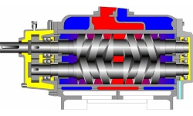

Screw Pump Advantages
- The intimate nature of the screws means volumetric efficiency is high versus other positive displacement pump designs
- A robust design and balanced nature enables very high pressures
- These pumps are intrinsically smooth and quiet
- The simplicity of design makes this pump relatively cheap to produce versus other rotary positive displacement pumps. They are also very much less effected by physical scale than say gear pumps and are often used for the bulk flow of oils for example over very long distances
- Viscous fluids that a centrifugal pump would be unable to handle are easily moved with a screw pump
- As the pumping action is quite finite, the output is very controllable. Doubling the size or speed, in theory simply doubles the output
- Unlike with a centrifugal pump, a screw pump’s output is loosely independent of discharge pressure altogether
- Not having to generate centrifugal forces to operate means that pump speeds can be low making them controllable, smooth and less disruptive
- The action makes screw pumps self-priming

- Subject to physical constraints such as motor power, casing strength, shaft sealing and to hydraulic factors such as volumetric efficiency the discharge pressure of a gear pump can be very high
- Centrifugal pumps have a Best Efficiency Point (BEP) which can be critical. This does not apply to screw pumps
- NPSHr for screw pumps is low versus centrifugal pump making them very useful where there is little net positive suction head available (NPSHa)
- Screw pumps are birotational
- Compared with other rotary positive displacement pumps they have no timing gears, are of ‘all metal’ construction and have only a single shaft to seal

Screw Pump Disadvantages
- As with all engineered equipment, screw pumps have a design envelope and when used outside of this will give a disappointing performance and/or a reduced life.
- Having long meshing screws makes this pump wholly unsuitable for solids or abrasive media and except in some very specific situations screw pumps are really only suitable for fluids with at least some inherent lubricity
- Screw pumps rely on precision clearances and have several rotating elements. This makes them more expensive to produce than a centrifugal pump
- Their ability to generate high pressure can also be a problem! If there is any risk of a ‘closed valve’ situation then a pressure relief valve and/or a pressure switch is essential to prevent a potentially hazardous situation from the pump causing excessive discharge pressures

Membrane pump (diaphragm pump)
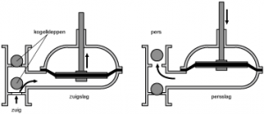

Advantages | Disadvantages
- Seal-less and oil-free | - Low maximum speed
- Self-priming up to 6 meters | - Not very energy efficient
- Simple cleaning/maintenance | - Pulsed flow - requires dampener for reduction
- Versatile design and function (can handle most media types)
- Can run dry for short periods

Liquid ring pump
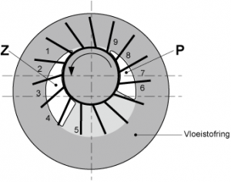

Vacuum pump is a device that works on the mechanism of suction to move air into or out of object. A liquid ring vacuum pump is easy to operate and is used in several applications across various industries. A liquid ring pump works with a sealant required in its operation. This liquid can be water, oil or any other solvent which is rotated by an impeller within the casing of the pump. The vacuum pumps that use water as sealant are called water ring vacuum pumps. When rotated this liquid forms air seals within the spaces between the impeller vanes which forms compression chambers that trap the air entering into pump frequently through the inlet port. This process repeats and therefore helps in creation of vacuum.
Unlike other pumps, which are used for only vacuum creation and pumping operations, a liquid ring vacuum pump can be used as a gas compressor as well. It can compress gas with its impeller rotating mechanism and is therefore a useful device for several applications. The vacuum pumps based on liquid ring technology are employed in several industries including paper, sugar, power, petrochemical, seawater deaeration, pharmaceutical, fertilizer, asbestos, oil refineries, distilleries, railways, textile, food, mineral etc. The best applications usually handled by these pumps include vacuum distillation, vacuum condensation, moisture extraction, ash or air handling, mineral beneficiation, evaporation jobs and liquid ring vacuum pump for removing water from paper pulp during paper processing.
The liquid ring pumps offer number of advantages over the other pumps and therefore are preferred in various applications. These pumps can easily take care of condensable vapors and can even handle fluids of various kinds without affecting the performance of the pump. Based on liquid ring technology, pumps have only one rotating or prime functioning part and therefore are economical and much easier to maintain than the other pumps. The repairing or rebuilding of these pumps is very easy in comparison to other complicatedly designed pumping units. Liquid ring vacuum pumps can efficiently be employed as vacuum jobs and also for the compression tasks as well which usually is not possible with ordinary pump sets. Being versatile these can be employed for several applications and therefore can provide an advantage of multiple functionalities to the user with just a single device

Advantages:
- Completely reliable operation
- Easy maintenance
- Simple yet highly functional structure
- Easy processing
- Compact design
- Little wear and tear due to no metal friction with the pump cavity surface
- Stable, reliable, and uniform results
Disadvantages:
- Efficiency is low, general about 30%, good is 50%.

- Vacuum degree is low, not only because this is limited by the structure of the, more important is restricted by working liquid saturation vapour pressure.Water as working fluid, the limit pressure can reach 2000 ~ 4000 pa.Oil as working fluid, up to 130 pa.

